# 64-channel electrode configuration for MEGIN Triux neo at CBU

Note: The numbers in the image do NOT refer to the sequence of electrodes in the data file. This sequence is specified in the column “Sequence in data” in below table.

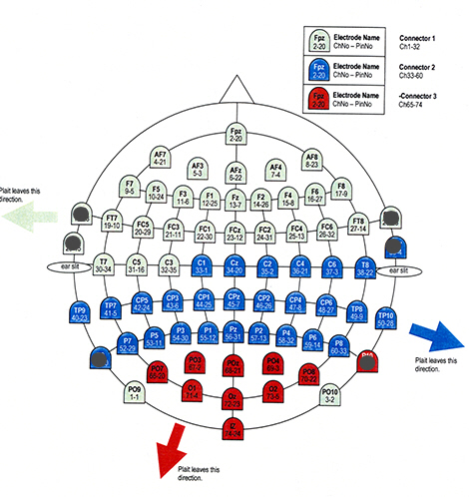

|  |  |  |
| --- | --- | --- |
| **Label** | **Sequence in data** | **Digitisation Order** |
| **PO9** | 1 | 1 |
| **FPz** | 2 | 2 |
| **PO10** | 3 | 3 |
| **AF7** | 4 | 4 |
| **AF3** | 5 | 5 |
| **Afz** | 6 | 6 |
| **AF4** | 7 | 7 |
| **AF8** | 8 | 8 |
| **F7** | 9 | 9 |
| **F5** | 10 | 10 |
| **F3** | 11 | 11 |
| **F1** | 12 | 12 |
| **Fz** | 13 | 13 |
| **F2** | 14 | 14 |
| **F4** | 15 | 15 |
| **F6** | 16 | 16 |
| **F8** | 17 | 17 |
| **PO4** | 18 | 59 |
| **FT7** | 19 | 18 |
| **FC5** | 20 | 19 |
| **FC3** | 21 | 20 |
| **FC1** | 22 | 21 |
| **FCz** | 23 | 22 |
| **FC2** | 24 | 23 |
| **FC4** | 25 | 24 |
| **FC6** | 26 | 25 |
| **FT8** | 27 | 26 |
| **PO8** | 28 | 60 |
| **O1** | 29 | 61 |
| **T7** | 30 | 27 |
| **C5** | 31 | 28 |
| **C3** | 32 | 29 |
| **C1** | 33 | 30 |
| **Cz** | 34 | 31 |
| **C2** | 35 | 32 |
| **C4** | 36 | 33 |
| **C6** | 37 | 34 |
| **T8** | 38 | 35 |
| **Oz** | 39 | 62 |
| **TP9** | 40 | 36 |
| **TP7** | 41 | 37 |
| **CP5** | 42 | 38 |
| **CP3** | 43 | 39 |
| **CP1** | 44 | 40 |
| **CPz** | 45 | 41 |
| **CP2** | 46 | 42 |
| **CP4** | 47 | 43 |
| **CP6** | 48 | 44 |
| **TP8** | 49 | 45 |
| **TP10** | 50 | 46 |
| **O2** | 51 | 63 |
| **P7** | 52 | 47 |
| **P5** | 53 | 48 |
| **P3** | 54 | 49 |
| **P1** | 55 | 50 |
| **Pz** | 56 | 51 |
| **P2** | 57 | 52 |
| **P4** | 58 | 53 |
| **P6** | 59 | 54 |
| **P8** | 60 | 55 |
| **Iz** | 61 | 64 |
| **PO7** | 62 | 56 |
| **PO3** | 63 | 57 |
| **POz** | 64 | 58 |
|  |  |  |