How to obtain a bootstrap confidence interval for a mediation effect using EXCEL 2007
EXCEL does not do bootstrapping by default however a bootstrap macro is available from http://www3.wabash.edu/econometrics/EconometricsBook/Basic%20Tools/ExcelAddIns/bootstrap.htm
- Download this macro and make sure the file has a .xla ending.
- You will then need to place this file in the folder on your hard drive which houses the EXCEL add-in programs. On my machine this is C:\Documents and Settings\peterw\Application Data\Microsoft\AddIns.
- You then need to add this file into EXCEL. Click the Microsoft Office Button , and then click Excel Options. Click the Add-Ins category. In the Manage box, click Excel Add-ins, and then click Go. To load an Excel add-in, in the Add-Ins available box, select the check box next to the add-in that you want to load, and then click OK.
- An Add ins tab should appear on the top menu. Clicking on this tap you should see the bootstrap option in the top left ‘menu commands’ section . We can now bootstrap in EXCEL FROM NOW ON so you will not need to repeat the above steps!
- Enter your data (upto 200 observations) in the green highlighted section in sheet 1 9see the attached MS EXCEL file for a worked example). These should be complete cases and comprise the outcome (Y), the mediator (M) and the independent variable (IV).
- Put the cursor in cell J2 in sheet 2 which corresponds to the ab mediator effect (the product of the two regression estimates in Sobel’s model). Click the Add-in tab and click bootstrap.
- You should get the following interface window:

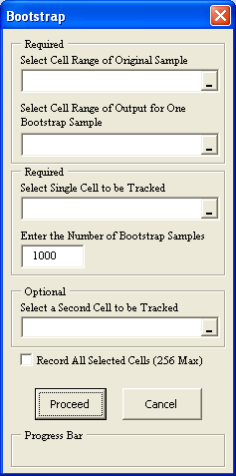
6. Place the cursor in the first cell (‘Select Cell Range of Original Sample’) and highlight all the data in the three columns (headed Y, M and IV) in Sheet 1. Now place the cursor in the second cell (‘Select Cell Range of Output for One Bootstrap Sample’) and highlight the same area (you just highlighted representing your input data) but in this time in Sheet 2. In the third cell (‘Select Single Cell to be Tracked’) highlight cell J2 in sheet 2 (corresponding to the ‘ab’ product). Check the box next to ‘Record All Selected Cells 9256 Max)’ and then click the ‘Proceed’ button.
7. The bootstrap macro should then do its stuff. Two new sheets should then appear called BootRaw and Bootstrap. Go to the BootRaw spreadsheet. This should give 1000 estimates of the mediation effect (one for each bootstrap sample). To obtain the 95% confidence interval for the mediation effect select two empty cells and in the first type =PERCENTILE(A2:A1001,0.025) and in the other empty cell type =PERCENTILE(A2:A1001,0.975)
These two numbers then represent the 95% confidence interval for the effect. If they contain zero there is no direct evidence of mediation however if the confidence interval does not contain zero then there is evidence of a statistically significant mediation effect.
(Further details of the bootstrap macro are available here in an attached word file which is also available on the bootstrap macro’s website acknowledged earlier).

